**Roll No :- 04**

**Name :- Rohan Vikas Badhe**

**Practical No :- 07**

**Practical Name :- Use git branch to create a new branch and**

comp@comp214 MINGW32 ~

$ git clone https://github.com/Utkarsha0510/KBCNMU.git

Cloning into 'KBCNMU'...

remote: Enumerating objects: 24, done.

remote: Counting objects: 100% (24/24), done.

remote: Compressing objects: 100% (19/19), done.

remote: Total 24 (delta 6), reused 3 (delta 0), pack-reused 0

Receiving objects: 100% (24/24), 1.25 MiB | 4.62 MiB/s, done.

Resolving deltas: 100% (6/6), done.

comp@comp214 MINGW32 ~

$ cd KBCNMU

comp@comp214 MINGW32 ~/KBCNMU (master)

$ git branch branch2

comp@comp214 MINGW32 ~/KBCNMU (master)

$ git checkout branch2

Switched to branch 'branch2'

comp@comp214 MINGW32 ~/KBCNMU (branch2)

$ touch MCA1.txt

comp@comp214 MINGW32 ~/KBCNMU (branch2)

$ git add MCA1.txt

comp@comp214 MINGW32 ~/KBCNMU (branch2)

$ git commit -m "First commit of branch2"

[branch2 9f81095] First commit of branch2

1 file changed, 0 insertions(+), 0 deletions(-)

create mode 100644 MCA1.txt

comp@comp214 MINGW32 ~/KBCNMU (branch2)

$ git push -u origin branch2

Enumerating objects: 4, done.

Counting objects: 100% (4/4), done.

Delta compression using up to 4 threads

Compressing objects: 100% (2/2), done.

Writing objects: 100% (3/3), 273 bytes | 273.00 KiB/s, done.

Total 3 (delta 1), reused 0 (delta 0), pack-reused 0

remote: Resolving deltas: 100% (1/1), completed with 1 local object.

remote:

remote: Create a pull request for 'branch2' on GitHub by visiting:

remote: https://github.com/Utkarsha0510/KBCNMU/pull/new/branch2

remote:

To https://github.com/Utkarsha0510/KBCNMU.git

* [new branch] branch2 -> branch2

branch 'branch2' set up to track 'origin/branch2'.

**Before Pull and merge on remote repository:**

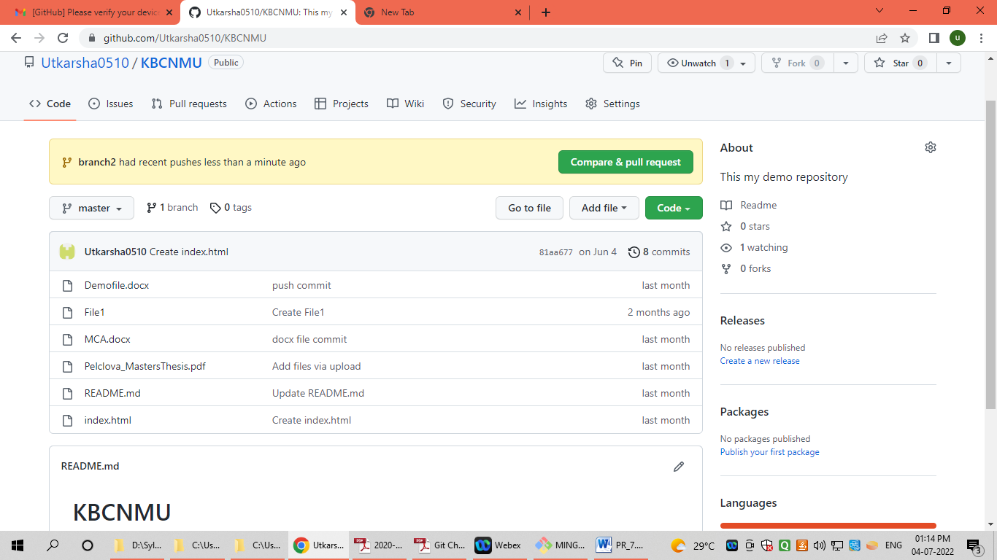

**Performing Pull request:**

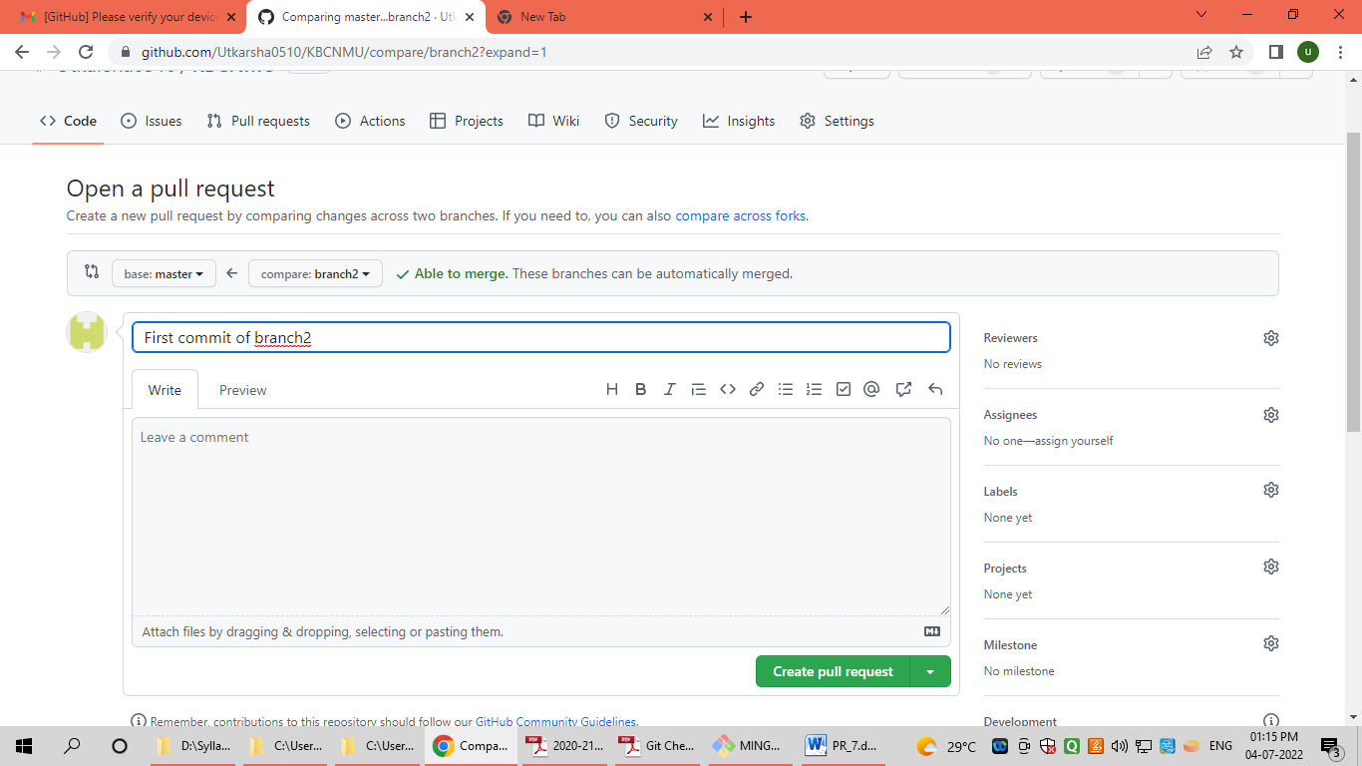

**After Pull performing Merge on remote repository at primary branch (master):**

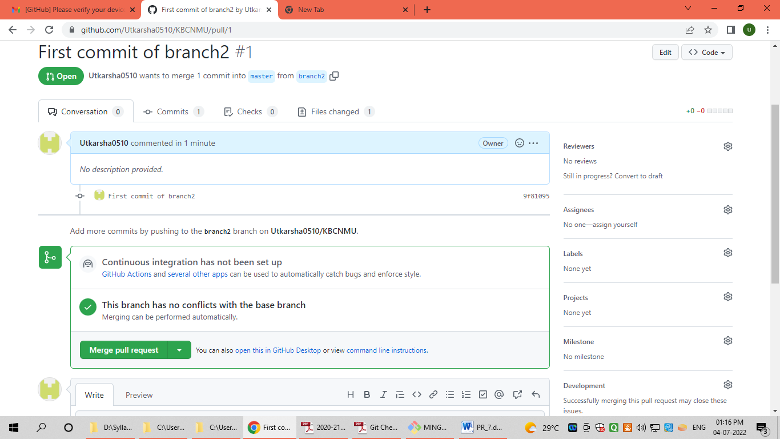

**After Merge from branch2 to primary branch (master) on remote repository:**

